17.19: a) so the
diameter is 1.9014 cm. b) 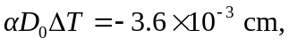so the diameter is 1.8964 cm.

